**PROJECT ABSTRACT**

**TOPIC: Wedding Dreamz**

**Submitted by:**

RESHMA R

S5 MCA Regular

Roll No:39

**Wedding Dreamz**

The “Wedding Dreamz” has been developed to override the problems prevailing in the practicing manual system. This system is designed for doing operations in a smooth and effective manner.

The main objective of this system is to provide more internet access to the users. It can manage catering, hall decoration, photography, dress, etc. It also allows to view the latest events and packages. Thus it will help organization in better utilization of resources.

**MODULES:**

There are two users in this project:

* Admin
* Users

**Admin**

* View the user details who are registered
* Update the packages or add packages
* Add or update the latest events
* Admin can reply quotation to the users with all requirements of users with estimated budget

**Users**

* Users can register
* Users can view the packages and latest events
* Users can send the requirements to the admin- The quotation send includes all the requirements of the wedding, budget, etc.
* Users can view the reply from admin in response to the quotation.
* Make payment if the package is available

**Functionalities provided are as follows:**

* Provides the details of wedding, event, package
* It tracks all the information of latest posts, quotation, package, etc.
* It deals with monitoring the information and transactions of package
* Editing, adding and updating of records is improved which results in proper resource management of wedding data.
* Manage the information of package

**USE CASE DIADRAM**

**Usecase Diagram for admin**

Catering Services

Hall Decoration

Studio

Wedding Dress

Admin

Management of events

Budget Estimation

**Usecase Diagram for user:**

Catering Services

Hall Decoration

Studio

Wedding Dress

User

**TABLES**

#### Table No 1 : tbl_login

**Primary key: login_id**

|  |  |  |  |  |
| --- | --- | --- | --- | --- |
| **SL No** | **Field name** | **Data type** | **Size** | **Description** |
| 1 | login_id | Int | 20 | Primary key |
| 2 | Username | varchar | 20 | Not null |
| 3 | Password | Varchar | 20 | Not null |
| 4 | login_status | Int | 10 | Not null |
| 5 | login_role | Int | 20 | Not null |

**Table No 2 : tbl_registration**

**Primary key : reg_id**

**Foreign key : login_id references tbl_login**

|  |  |  |  |  |
| --- | --- | --- | --- | --- |
| **SL No** | **Field name** | **Data type** | **Size** | **Description** |
| 1 | reg_id | Int | 20 | Primary key |
| 2 | login_id | Int | 20 | Foreign key |
| 3 | reg _name | Varchar | 30 | Not null |
| 4 | reg_place | Varchar | 50 | Not null |
| 5 | reg_phone | Varchar | 10 | Not null |
| 6 | reg_email | Varchar | 30 | Not null |
| 7 | reg_status | Int | 10 | Not null |

**Table No 3 : tbl_caste**

**Primary key :caste_id**

|  |  |  |  |  |
| --- | --- | --- | --- | --- |
| **SL No** | **Field name** | **Data type** | **Size** | **Description** |
| 1 | caste_id | Int | 10 | Primary key |
| 2 | caste_name | Varchar | 30 | Not null |

**Table No 4 : tbl_religion**

**Primary key : religion_id**

**Foreign key : caste_id references tbl_caste**

|  |  |  |  |  |
| --- | --- | --- | --- | --- |
| **SL No** | **Field name** | **Data type** | **Size** | **Description** |
| 1 | religion_id | Int | 10 | Primary key |
| 2 | Caste_id | Int | 10 | Foreign key |
| 3 | religion_name | Varchar | 30 | Not null |

**Table No 5 : tbl_userdetails**

**Primary key : user_id**

**Foreign key : caste_id references tbl_caste**

|  |  |  |  |  |
| --- | --- | --- | --- | --- |
| **SL No** | **Field name** | **Data type** | **Size** | **Description** |
| 1 | user_id | Int | 10 | Primary key |
| 2 | Caste_id | Int | 10 | Foreign key |
| 3 | bride_name | Varchar | 20 | Not null |
| 4 | groom_name | Varchar | 20 | Not null |
| 5 | bride_address | Varchar | 100 | Not null |
| 6 | groom_address | Varchar | 100 | Not null |

**Table No 6 : tbl_package**

**Primary key : package_id**

|  |  |  |  |  |
| --- | --- | --- | --- | --- |
| **SL No** | **Field name** | **Data type** | **Size** | **Description** |
| 1 | package_id | Int | 10 | Primary key |
| 2 | package_name | Varchar | 30 | Not null |
| 3 | Rate | Int | 20 | Not null |

**Table No 7 : tbl_catering**

**Primary key : cat_id**

**Foreign key :package_id references tbl_package**

|  |  |  |  |  |
| --- | --- | --- | --- | --- |
| **SL No** | **Field name** | **Data type** | **Size** | **Description** |
| 1 | cat_idPrimary | Int | 10 | Primary key |
| 2 | package_id | Int | 10 | Foreign key |
| 3 | Food_type | Varchar | 30 | Not null |
| 4 | Food_name | Varchar | 30 | Not null |
| 4 | food_image | Varchar | 100 | Not null |
| 5 | food_description | Varchar | 100 | Not null |
| 6 | food_price | Int | 20 | Not null |
| 7 | food_status | Int | 10 | Not null |

#### Table No 8 : tbl_hall_decor

**Primary key : hall_id**

**Foreign key :package_id references tbl_package**

|  |  |  |  |  |
| --- | --- | --- | --- | --- |
| **SL No** | **Field name** | **Data type** | **Size** | **Description** |
| 1 | hall_idPrimary | Int | 10 | Primary key |
| 2 | package_id | Int | 10 | Foreign key |
| 3 | decor_type | Varchar | 30 | Not null |
| 4 | stage_name | Varchar | 30 | Not null |
| 5 | stage_image | Varchar | 60 | Not null |
| 6 | stage_description | Varchar | 100 | Not null |
| 7 | stage_price | Int | 20 | Not null |
| 8 | stage_status | Int | 10 | Not null |

**Table No 9 : tbl_studio**

**Primary key : studio_id**

**Foreign key :package_id references tbl_package**

|  |  |  |  |  |
| --- | --- | --- | --- | --- |
| **SL No** | **Field name** | **Data type** | **Size** | **Description** |
| 1 | studio_id | Int | 10 | Primary key |
| 2 | package_id | Int | 10 | Foreign key |
| 3 | s_package | Varchar | 30 | Not null |
| 4 | Price | Int | 20 | Not null |
| 5 | studio_name | Varchar | 30 | Not null |
| 6 | photo_image | Varchar | 100 | Not null |
| 7 | studio_address | Varchar | 100 | Not null |
| 8 | studio_phone | Varchar | 30 | Not null |
| 9 | photo_status | Int | 10 | Not null |

**Table No 10 : tbl_dress**

**Primary key : dress_id**

**Foreign key :package_id references tbl_package**

|  |  |  |  |  |
| --- | --- | --- | --- | --- |
| **SL No** | **Field name** | **Data type** | **Size** | **Description** |
| 1 | dress_id | Int | 10 | Primary key |
| 2 | package_id | Int | 10 | Foreign key |
| 3 | dress_type | Varchar | 30 | Not null |
| 4 | color | Varchar | 30 | Not null |
| 5 | Price | Int | 20 | Not null |
| 6 | dress_image | Varchar | 100 | Not null |
| 7 | dress_status | Int | 10 | Not null |

**Table No 11 : tbl_ event**

**Primary key : event_id**

**Foreign key : reg_id references tbl_registration**

|  |  |  |  |  |
| --- | --- | --- | --- | --- |
| **SL No** | **Field name** | **Data type** | **Size** | **Description** |
| 1 | event_id | Int | 10 | Primary key |
| 2 | Reg_id | Int | 10 | Foreign key |
| 3 | Date | Varchar | 50 | Not null |

**Table No 12 : tbl_ bank**

**Primary key : bank_id**

|  |  |  |  |  |
| --- | --- | --- | --- | --- |
| **SL No** | **Field name** | **Data type** | **Size** | **Description** |
| 1 | bank_id | Varchar | 30 | Primary key |
| 2 | bank_name | Varchar | 30 | Not null |
| 3 | bank_ branch | Varchar | 30 | Not null |
| 4 | bank_IFSCcode | Varchar | 30 | Not null |

**Table No 13: tbl_ payment**

**Primary key : pay_id**

|  |  |  |  |  |
| --- | --- | --- | --- | --- |
| **SL No** | **Field name** | **Data type** | **Size** | **Description** |
| 1 | pay_id | Int | 20 | Primary key |
| 2 | pay_types | Varchar | 30 | Not null |

#### Table No 14 : tbl_ account

**Primary key : acc_id**

|  |  |  |  |  |
| --- | --- | --- | --- | --- |
| **SL No** | **Field name** | **Datatype** | **Size** | **Description** |
| 1 | acc_id | Int | 10 | Primary key |
| 2 | acc _no | Varchar | 30 | Not null |
| 3 | acc_pin | Int | 20 | Not null |
| 4 | acc_cardno | Varchar | 30 | Not null |
| 5 | acc_balance | Int | 20 | Not null |
| 6 | acc_status | Int | 10 | Not null |

**Data Flow Diagram**

**Level -0**

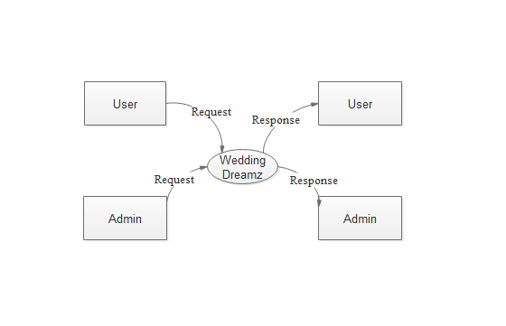

**Admin Level-1**

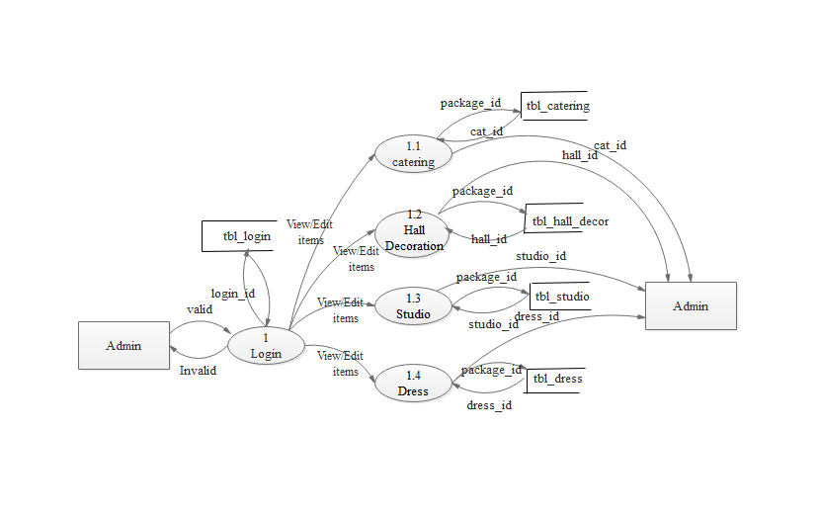

**Registered User Level-1**

